sto poster presentetations na valoume kai auto
- For poster presentations
Posters will be on displays throughout the conference. The dimensions of the poster should not exceed 60cm x 80cm and must be portrait oriented.
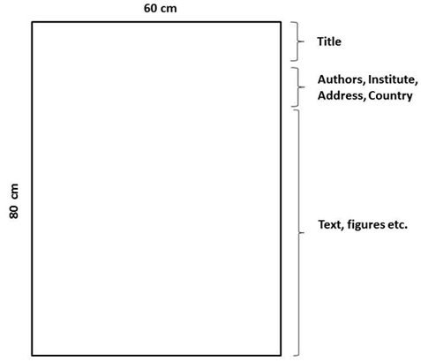

Aristidis P. BITZENIS, PhD, bitzenis@gmail.com
Associate Professor of Global Entrepreneurship & FDI,
University of Macedonia, Department of International and European Studie

